ZAD 1

a)

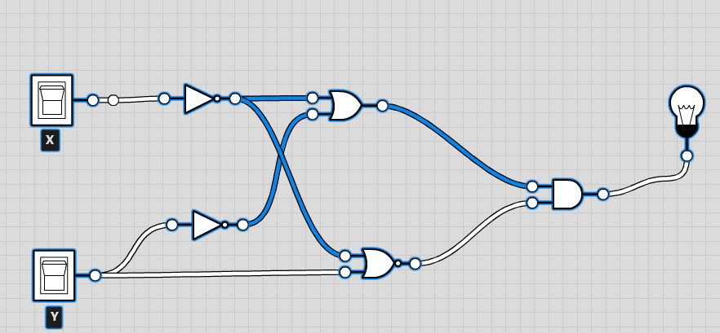

|  |  |  |
| --- | --- | --- |
| x | y | **f** |
| 0 | 0 | **0** |
| 0 | 1 | **0** |
| 1 | 0 | **1** |
| 1 | 1 | **0** |

b)

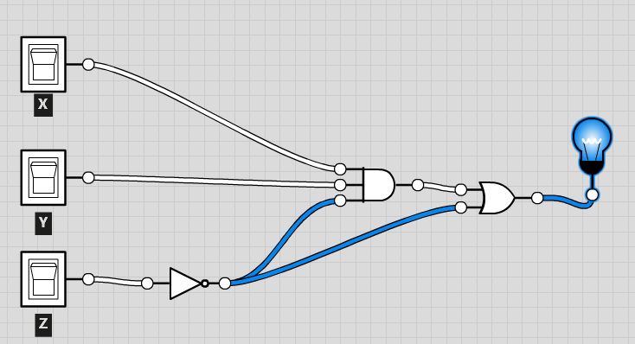

|  |  |  |  |
| --- | --- | --- | --- |
| x | y | z | **f** |
| 0 | 0 | 0 | **1** |
| 0 | 0 | 1 | **0** |
| 0 | 1 | 0 | **1** |
| 0 | 1 | 1 | **0** |
| 1 | 0 | 0 | **1** |
| 1 | 0 | 1 | **0** |
| 1 | 1 | 0 | **1** |
| 1 | 1 | 1 | **0** |

c)

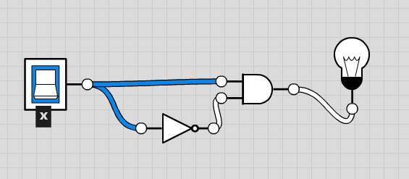

|  |  |
| --- | --- |
| x | **f** |
| 0 | **0** |
| 1 | **0** |

d)

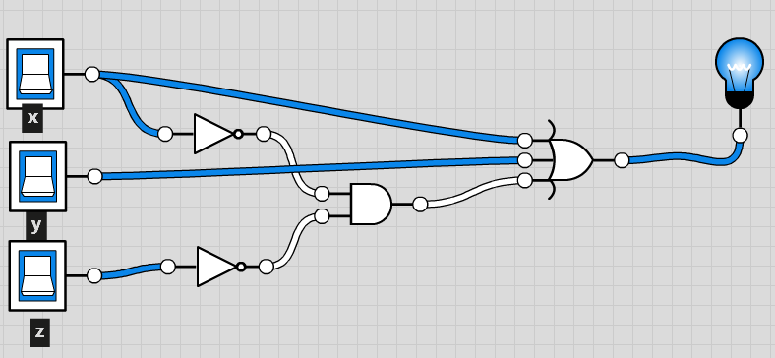

|  |  |  |  |
| --- | --- | --- | --- |
| x | y | z | **f** |
| 0 | 0 | 0 | **1** |
| 0 | 0 | 1 | **0** |
| 0 | 1 | 0 | **1** |
| 0 | 1 | 1 | **1** |
| 1 | 0 | 0 | **1** |
| 1 | 0 | 1 | **1** |
| 1 | 1 | 0 | **1** |
| 1 | 1 | 1 | **1** |

ZAD 2

Subtraktor jednobitowy

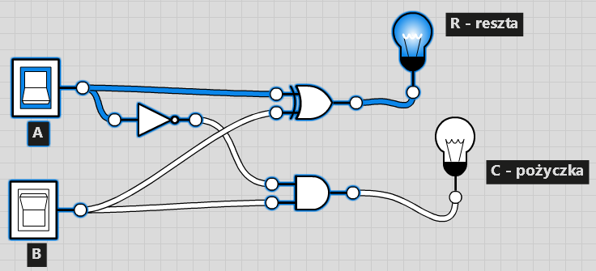

ZAD 3

f(a,b,c) ~(a ∩ b ∩ c) ∩ (~a ∪ ~b ∪ c ) ∩ (a ∩ ~c) ∩ (a ∪ ~b ∪ c)

|  |  |  |  |
| --- | --- | --- | --- |
| a | b | c | **f** |
| 0 | 0 | 0 | **0** |
| 0 | 0 | 1 | **0** |
| 0 | 1 | 0 | **0** |
| 0 | 1 | 1 | **0** |
| 1 | 0 | 0 | **1** |
| 1 | 0 | 1 | **0** |
| 1 | 1 | 0 | **0** |
| 1 | 1 | 1 | **0** |